Stacey Funt, MD
Lifestyle-health.net
Lifestylehealthllc@gmail.com

RAISED GARDEN BED INSTRUCTIONSGLUTEN FREE COOKING

I am a novice gardener but I find that if I plant in good soil, water and expose to sun... it shall grow! I love to garden in raised beds for the ease on my back and the aesthetics. There are many raised beds you can buy in the store or online but if you want a special size or are on a budget, you can easily make your own. Here are the steps I took:

- Design where you want to put your bed and measure the space.

- Determine the measurements of the pieces of your box. You are going to get four side planks that make up the walls of the box and four 4x4 pieces of wood for the corner posts (the bigger parts on the inside of the corners). If you are putting this on dirt, your box will be more secure if you have longer planks that can be set in the ground vertically. If you are putting this on a rooftop or don’t want to dig any holes, then you will make the posts the height of your planks). Here is a photo of one of my completed beds so you see what I am talking about.

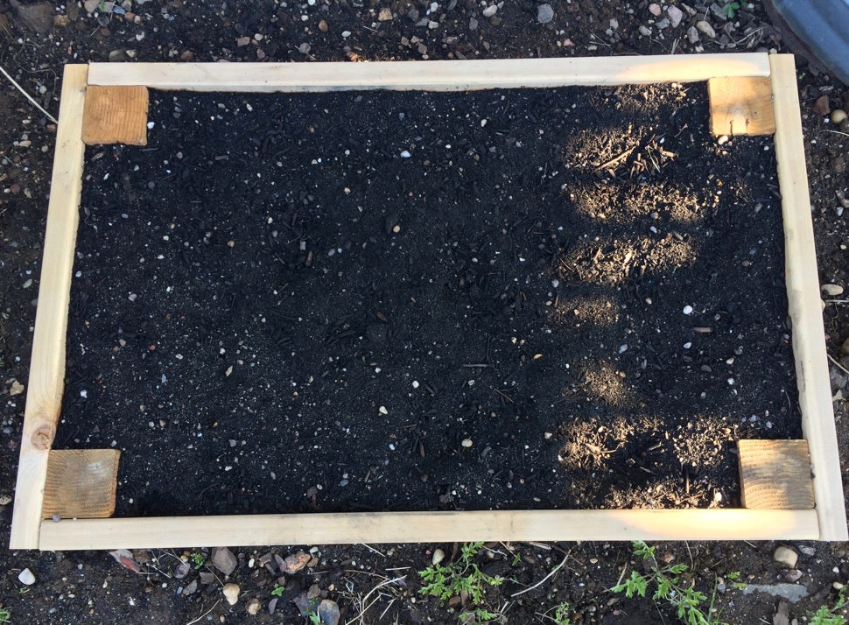
See how the boards are placed to take into account overlap as you calculate your measurements. You are going to put together the box first, then dig a hole in the ground for each of the posts. The posts usually go in about a foot so if the height of your wood is 6 inches, you will want each post to be about 18 inches.

- Buy the wood. I used untreated cedar wood. I bought it from Home Depot and brought my measurements with me. They cut the wood to size right there so all I had to do was take it home and nail it together. For two boxes around 2 ½ x 3 ½ feet, it cost $90. You can use cheaper wood but this is supposed to last a long time. Composite wood is also a less expensive option and I have heard the way they make some of the newer composites minimizes the risk of chemicals leaching into the soil. You may want to research this further to determine your comfort level. Some people stain the wood but I wanted this to be easy and it’s going to turn gray soon anyway. If you do want to paint or stain, again, be mindful of the chemicals in the products you are using and how it might affect your soil. I also bought a box of 3 inch nails to put the pieces together. The planks I got are 6 inches high. That was enough for me. If you want a taller box, you can double the sides and put one of top of the other. Be sure to get longer posts in that case.

- Prepare your ground. You can put a garden box anywhere. I was putting it on top of old dirt which was hard and dry. The garden center told me to dig up some of that dirt and mix it with organic compost and vermiculite (white clumped particles that improve the drainage of the soil). I added a few shovels of both to the ground beneath and mixed. Okay, so it was my birthday when we did this and my husband very lovingly did all the digging but you can do it yourself. Next, we dug four holes for the legs to go into the ground and were ready to build the box.

- Build your box! Start with one of the 4 x 4 posts and nail the longer side plank onto the upper portion of it. Then, nail the other side of that plank to a second 4 x 4 post. You now have one side of your box with two posts sticking down. Do the same with the other longer plank of wood and you have two sides. Then, nail the shorter plank of wood to the two 4 x 4s to complete a third side and do once more to complete the box. This part is tricky. Full disclosure-my husband did most of this. He held and I hammered some. It will be easier to have two people for this unless you are pretty handy.

- Place the box in the ground. Now, the fun begins. Put the box in the ground with the long posts going into your holes in the ground. You may have to adjust a little to fill in the space around the posts and make it level.

- Fill you box with soil. Soil is key! I went to the garden center and told them the measurement of my box (including the height) and they told me how many yards of dirt I needed. I got half soil and half compost and mixed it together as we filled the boxes. Some people put down weed guard around the boxes so weeds are more manageable.

- Plant! YAY! You have your raised garden bed. Now, plant what you enjoy!

Copywrite © Lifestyle Health LLC 2016

